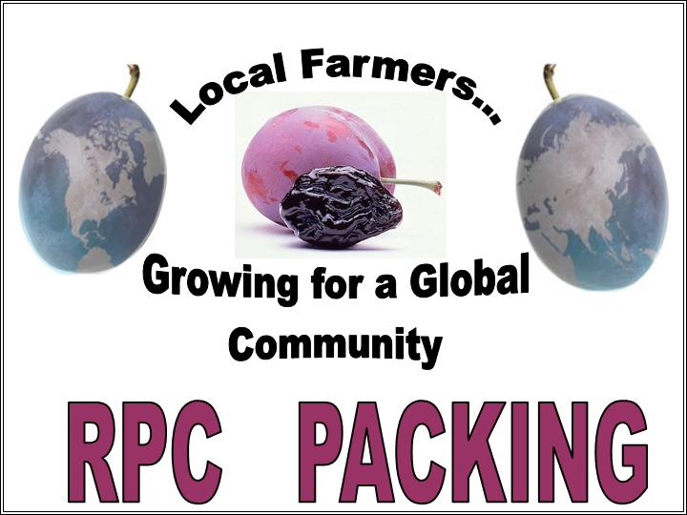

Prune Juice- Not from Concentrate
Packaging Options*:
Cans: 46 oz and 5 1/2 oz (pull top)
PET: 32 oz, 48 oz and 64 oz
*Others available upon request

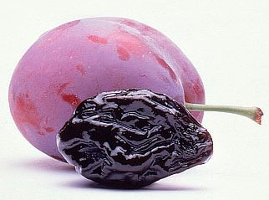
Canned Prunes (Any Size)

Sizes Available*:
#10 Cans
300 Can
*Others available upon request
Bins (1 Ton)
Boxed (Various Sizes)
Bagged (DOY or Pillow)
Sorbated
Pitted/Unpitted
Natural Condition
Many Other Options Available!

